React Hooks, JSON, HTTP, & Express
Working with your Trio/Buddy:
- Discuss: If you could change one thing about the world, what would it be?
- Reflection: What's been the most valuable thing you've learned from your trio so far?
- Explore: Break down the relationship between HTTP requests, APIs, and Express

Review React Hooks
The best way to learn about the use of React Hooks, especially react useState(), is practicing. Please try to follow or code along with the TODO App exercise in the lesson. Don’t do the other exercises. You don’t need to use useReduce() or useContext() just yet. Please, just focus on being able to write a TODO App using useState(). You will learn about more hooks in week

An Introduction to JSON
JSON — short for JavaScript Object Notation — is a format for sharing data. As its name suggests, JSON is derived from the JavaScript programming language, but it’s available for use by many languages including Python, Ruby, PHP, and Java. JSON is usually pronounced like the name “Jason.”

Intro to HTTP
Primary takeaway – HTTP is the protocol used to pass data around the internet.

HTTP Requests
HTTP is the most common way you will retrieve anything from the internet: usually web pages or API data (see API & JSON lesson). It's the backbone of the web. Since HTTP is so simple and versatile (it's just text!), you can make requests in lots of different ways. In today’s HTTP Request Lesson, you will learn how to use the following:
- Basics of an HTTP Request
- There are six different ways to make an HTTP request. For now, your lesson will help you to understand how to use:
  - Postman (Mac GUI app) You can follow the lesson in the Techtonica curriculum or you can read the official documentation
  - Curl. You can follow the lesson in the Techtonica curriculum, or you can try these extra exercises:
    - How to easily use curl
    - Curl by Julia Evans
  - http.request in Node.js - don’t use, this is deprecated
    - Official documentation
  - fetch in Node.js
    - Official examples

APIs & JSON
APIs let you access a wealth of services available on the Internet, both free and paid. Unlike some older formats, JSON is easy for both computers and humans to work with, and is natively supported by JavaScript (and many other languages).

The only way of getting comfortable using API is by practicing. We highly encourage you to do the Independent Practice of this lesson.

Express
Express.js is one part of the PERN web development stack (PostgreSQL, Express.js, React.js, Node.js), which we cover at Techtonica. Express.js allows you to quickly build a website served by Node.js. Express enables robust routing and improves performance. It is flexible as there are numerous modules available on npm which can be directly plugged into Express.

A common complicated topic with Express is what are middleware functions? Here is a simple explanation of that topic
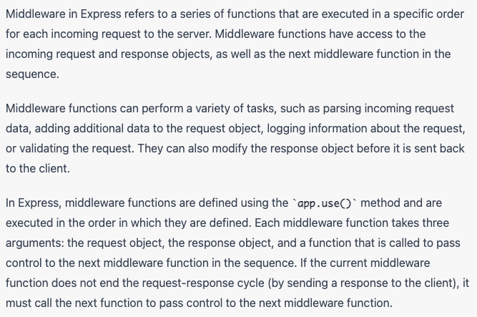

Note: Computers also have middleware, so if you are googling and it says something about operating systems or hardware then you are looking at the wrong type of middleware. Make sure you are looking for web middleware. Express is a middleware, not all middleware is Express.

CSS Topic: CSS Icons
With CSS you can use the icon library you like, such as:
- Font Awesome Icons
- Google Material Design Icons
- Bootstrap Icons

💡Continue Working on Your Weekly Project: Game App

Skills you should have at the end of the day:
- Create a basic web app using Node.js for the server and Express.js as the MVC framework

End-of-day Questions:

React Hooks
- Why use hooks?
- When to use useState hook - How can I store state and change state using useState?

HTTP
- What is the HTTP standard?
- HTTP Request (Get, Post, Put, & Delete)
- HTTP Response
- HTTP Header
- HTTP Status Codes
  - 1xx informational
  - 2xx Success
  - 3xx Redirect
  - 4xx Client error
  - 5xx Server error

APIs & JSON

What is an API
- What is JSON
- What is the syntax and structure of JSON
- What is the syntax difference between JSON and a Javascript Object?
- What are serialization and deserialization?
- How does one read data from a JSON?

Express
- What is Express?
- How do you use Express in JS?
- What is a route?
- What is middleware? (NOTE: if your resource talks about an operating system you are looking at the wrong thing, make sure you are looking at web middleware)
- Explain the MVC architectural pattern

EOD Quiz: React, JSON, & HTTP Requests

